Supporting information
Genome description of the endangered pen shell Pinna nobilis : a giant bivalve experiencing a mass mortality event
Robert Bunet^{1†*}, Jean-Marc Prévot², Nardo Vicente^{1,3}, José Rafa García-March⁴, Rajko Martinović⁵, José Tena-Medialdea⁴, Danijela Joksimovic⁵, Jean-Luc Bonnefont¹, Stéphane Coupé^{6†*}

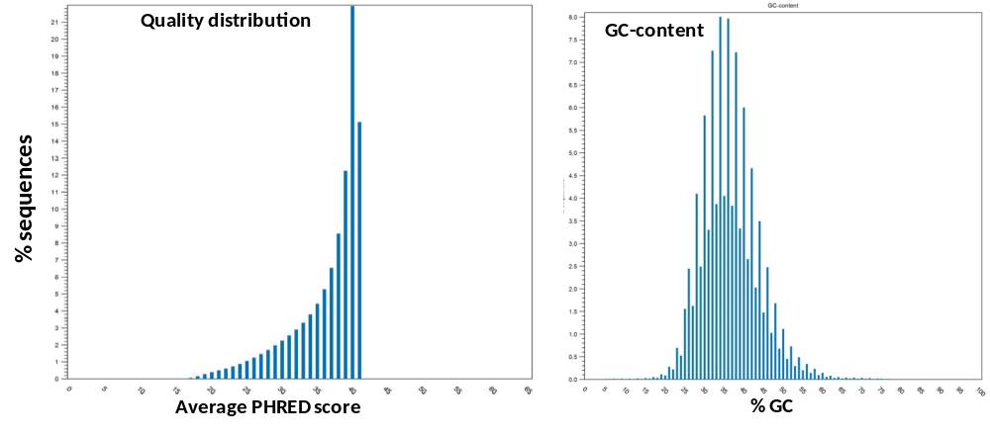
Fig. S1. Sequencing quality check and GC content
Left : Q-score distribution data from the sample. Mean quality score is 36.46. Right : distribution of GC-content in the sequencing sample.

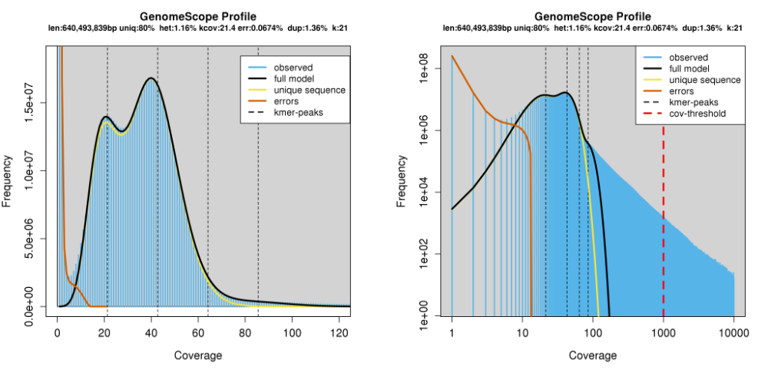
Figure S2. k-mer frequency distribution profile
This profile has been obtained using Genomescope (http://qb.cshl.edu/genomescope/), based on the histogram data generated with JELLYFISH, for an optimal k-mer size = 23. The two peaks observed at 21X and 40X coverages account for the proportion of heterozygous and homozygous regions, respectively.

Table S1. Summary NGS data, statistics and quality of the assembly.
Clusters (Raw) | Clusters (PF) | Yield (MBases) | % >=Q30 | Mean quality score
1,242,422,208 | 7,92,312,851 | 239,278 | 85,63 | 36,46

 | Count | Average length | Total bases
Reads | 1,388,469,937 | 136.07 | 188,933,666,558
Matched | 1,240,281,960 | 135.95 | 168,617,807,287
Not Matched | 148,187,977 | 137.1 | 20,315,859,271
Contigs (all) | 97,633 | 6,012 | 586,482,772
Reads in pairs | 799,236,714 | 286.81
Broken paired reads | 339,580,380 | 133.13

Nucleotide | Count | Frequency (%)
Adenine (A) | 186,647,981 | 32
Cytosine (C) | 104,061,672 | 17.8
Guanine (G) | 104,082,746 | 17.8
Thymine (T) | 186,629,547 | 32
Any nucleotide (N) | 2451437 | 0.4

 | Length
N75 | 4,360
N50 | 7,613
N25 | 13,225
Minimum | 1,976
Maximum | 76,768
Average | 6,036
Contig count (PF) | 96,738
Total | 583,873,383

Table S2. Number of protein-coding contigs related to the innate immunity.
Immunity | Gene families | Number of genes
Pattern recognition | Toll-like receptors (TLRs) | 27
receptors | Peptidoglycan recognition receptors (PGRPs) | 6
and antimicrobial | Glucan Binding proteins (GNBPs) | 8
peptides | Lectins | 33
 | Collectins | 1
 | Laminins | 7
 | DDX helicases | 1
 | MDA5 (interferon-induced with helicase-C domain 1) | 1
 | Soluble scavenger receptor cysteine-rich peptides | 3
 | Cysteine-rich secretory proteins (CRISPs and LCCL domain-2) | 3
 | Cysteine-rich venom protein | 2
 | Bactericidal permeability-increasing protein | 3
 | Lysosome | 3
TLR pathway | MyD88 | 5
 | IRAK1 | 1
 | IRAK3 | 1
 | IRAK4 | 1
 | TRAF | 7
Transcription factors | NF-kB (c-Rel) | 1
 | Interferon regulatory factor | 3
Cytokines and | Interleukin (IL 17-like) | 12
receptors | Interleukin 25 | 1
 | Interferon regulatory factor | 3
 | LPS-induced TNF (LITAF) | 4
 | TNF super family | 7
 | Macrophage migration inhibitory factor (MIF) | 1
Complement system | C3 | 3
 | C6 | 2
 | C8 | 1
 | macrophage-expressed gene 1 protein-like (IPR020864) | 4
Apoptosis & autophagy | Caspases | 13 (of which 2 with a CARD domain and 2 with a DED domain)
 | Apoptosis-inducing factor 1, mitochondrial-like | 1
 | Inhibitor of apoptosis | 1
 | BCl-2 | 2
 | Bax | 1
 | DAMPs | 5

Table S3. Number of protein-coding contigs related to the chemical defensome.
Process categories | Gene families |  | Number of genes
Reductive and conjugative | Sulfotransferase (SULT) | 28
biotransformation | Glycosyl-transferase (UGT) | 21
 | Glucuronyl-transferase (UGT) | 3
 | Epoxyde hydrolase (EPHX) | 3
 | Aldo/keto reductase | 2
 | Gluthatione S-transferase (GST) | 15
 | N-acetyl transferase (NAT) | 6
Antioxydant proteins & | Catalase (CAT) | 1
Metal detoxification | Superoxide dismutase [Cu/Zn] (SOD) | 2
 | Superoxide dismutase [Mn] (SOD) | 1
 | Gluthatione peroxydase | 2
 | Gluthatione synthase | 1
 | Gluthatione reductase | 1
 | Metallothionein | 1
 | Heavy metal-binding protein HIP-like | 7
 | Ferritin | 2
 | Ceruloplasmin | 1
 | Biliverdin reductase | 1
Heat shock proteins/factors | Hsp70 | 7
 | Hsp70 cognate | 1
 | Hsp90 | 1
 | DnaJ (hsp40) | 17
 | Sti1 | 1
 | Hsp70, mitochondrial | 2
 | Hsp60, mitochondrial | 2
 | Hsp10, mitochondrial | 1
 | Hsf | 1
Oxydative biotransformation | Aldehyde dehydrogenase | 4
 | Cytochrome P450 | 98
 | Flavin-monooxygenase | 3
Efflux transporters | ABCA | 12
 | ABCB | 7
 | ABCC | 21
 | ABCD | 1
 | ABCF | 2
 | ABCG | 9
Nuclear receptors | Subfamily NR0
 | Dax1 | 1
 | Subfamily NR1
 | Ecdysone receptor | 1
 | PPARα | 1
 | PPARδ | 1
 | PPARγ | 2
 | Retinoic acid receptor (RAR) | 6
 | Rev-ErbA | 1
 | Orphan nuclear receptor (PXR) | 1
 | Subfamily NR2
 | NR2E1 (TLX) | 3
 | hepatocyte nuclear factor | 1
 | Subfamily NR3
 | EERβ | 2
 | Glucocorticoid receptor | 1
 | Subfamily NR4
 | HR38 | 1
 | Subfamily NR5
 | NR5A | 1
 | Other NR
 | AhR (class E basic helix-loop-helix protein 22) | 1
 | CLOCK | 4
 | ARNT | 4
Transcription factors | BACH1 | 5
 | MafK | 2
 | HIF-1 | 3
 | Other hypoxia-related genes | 3
 | Mtf1 | 1
 | Keap1 | 1
 | Nfe2 | 2

Table S4. Variant calling analysis.

CHROM | POS | REF | ALT | QUAL | INFO | FORMAT | PN-new_S1_R2_q30_bwt.sorted.bam
Contig_66 | 6 | AAAT | AAATGGGAAAT | 225 | INDEL;IDV=1;IMF=0.00452489;DP=221;VDB=1.20757e-12;SGB=-0.692067;MQSB=0.83135;MQ0F=0;AC=2;AN=2;DP4=0,0,11,9;MQ=40 | GT:PL | 1/1:255,60,0
Contig_66 | 18614 | T | C | 109 | DP=1735;VDB=0.00102431;SGB=-0.693147;RPB=3.13516e-15;MQB=4.1025e-09;MQSB=3.65631e-13;BQB=0.948889;MQ0F=0;ICB=1;HOB=0.5;AC=1;AN=2;DP4=403,566,172,162;MQ=39 | GT:PL | 0/1:143,0,255
Contig_66 | 18629 | C | T | 99 | DP=1645;VDB=0.00678981;SGB=-0.693147;RPB=1.24972e-06;MQB=3.63726e-29;MQSB=3.90431e-05;BQB=0.0813158;MQ0F=0;ICB=1;HOB=0.5;AC=1;AN=2;DP4=466,513,137,161;MQ=40 | GT:PL | 0/1:133,0,255
Contig_66 | 18647 | A | G | 211 | DP=1559;VDB=8.97541e-05;SGB=-0.693147;RPB=0.54288;MQB=2.46024e-38;MQSB=0.993164;BQB=6.00232e-05;MQ0F=0;ICB=1;HOB=0.5;AC=1;AN=2;DP4=352,433,172,206;MQ=40 | GT:PL | 0/1:244,0,255
Contig_66 | 18677 | G | A | 222 | DP=1067;VDB=7.40422e-32;SGB=-0.693147;RPB=0.65428;MQB=2.79887e-22;MQSB=0.604942;BQB=0.946848;MQ0F=0;ICB=1;HOB=0.5;AC=1;AN=2;DP4=309,201,127,153;MQ=40 | GT:PL | 0/1:255,0,255
Contig_66 | 18736 | T | C | 222 | DP=414;VDB=0;SGB=-0.693147;RPB=0.0679321;MQB=1.15086e-11;MQSB=0.581019;BQB=0.407082;MQ0F=0;ICB=1;HOB=0.5;AC=1;AN=2;DP4=80,73,92,23;MQ=40 | GT:PL | 0/1:255,0,255

